First, we load all the libraries we need.

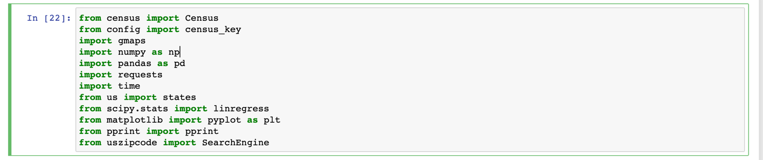

We then pull Census data including Population, Median Household Income, Per Capita Income by Zip Code and set up a dataframe.

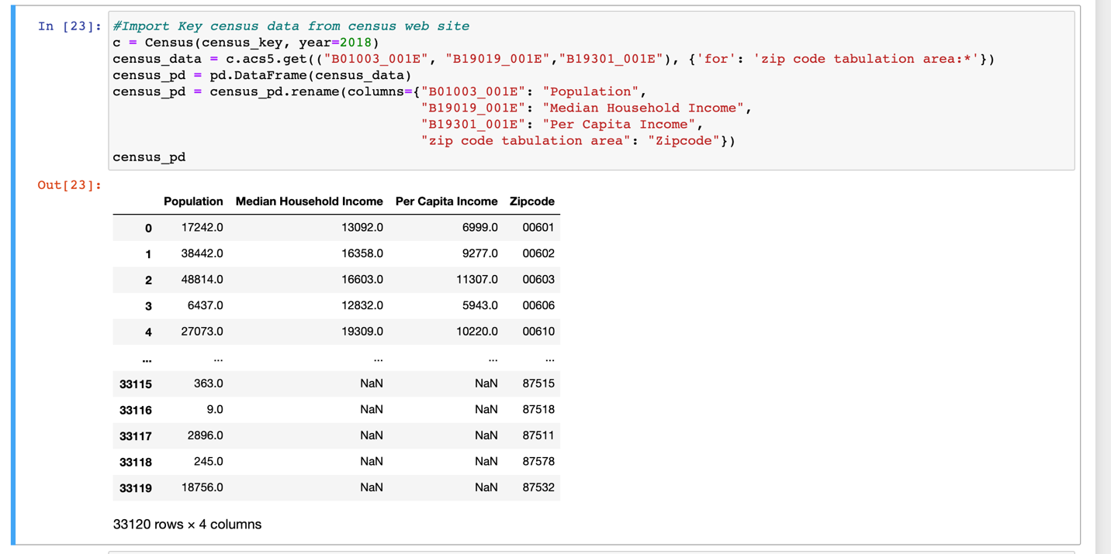

A quick view of the json to see what fields we need to pull

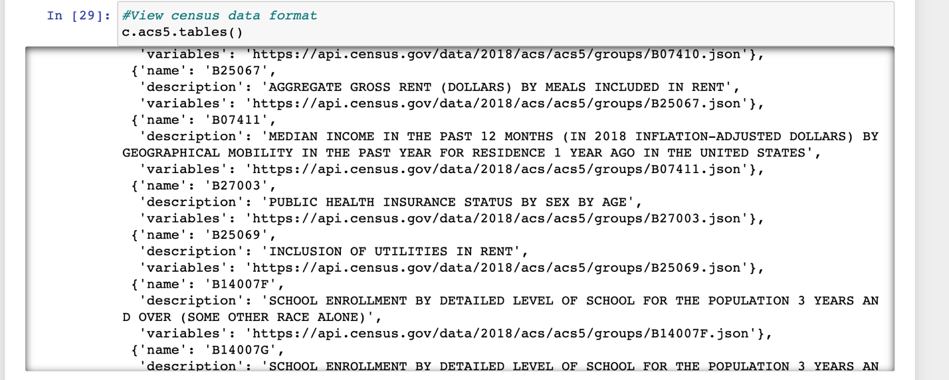

Export the file as a CSV to Excel



Since the Census data is grouped by Zip code, and we want the data in County and State, we used the Pypi api’s SearchEngine to run all 33 thousand plus zip codes through a loop to associate each zip code with its corresponding County and State.

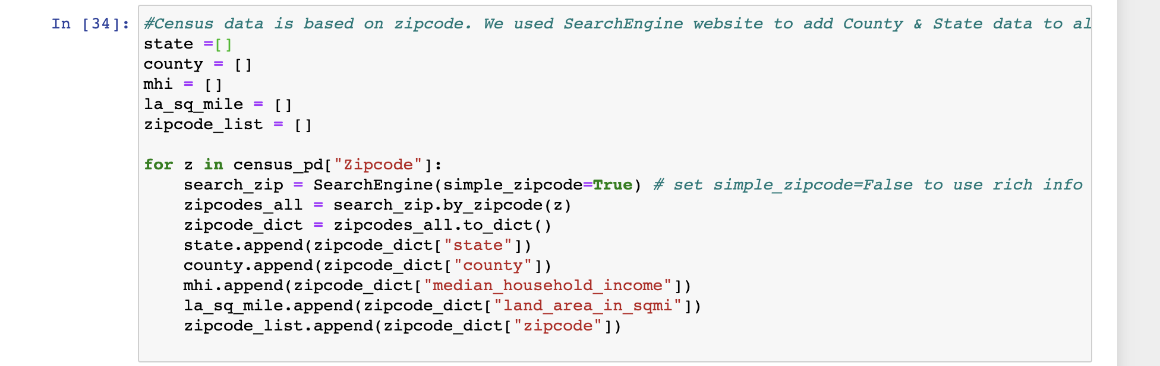

I quick look at the json to confirm the fields we needed.

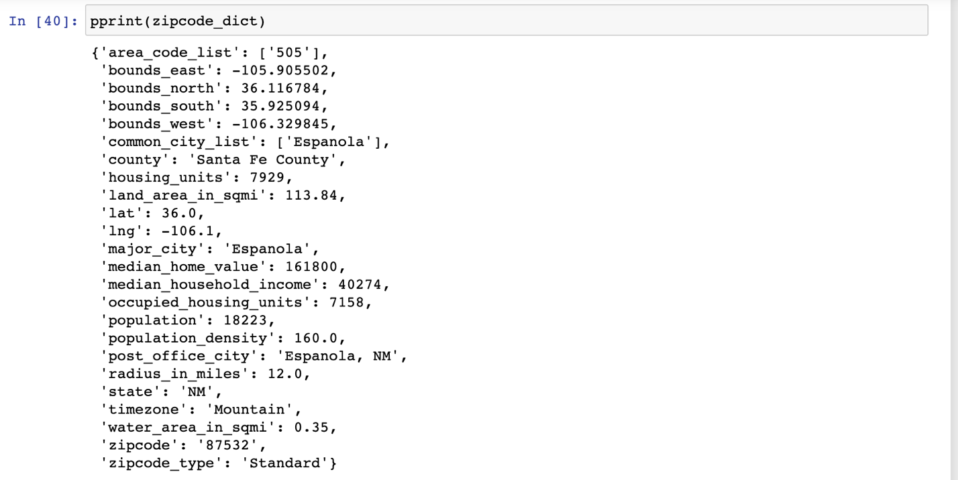

Here’s the new dataframe which now includes County and State.

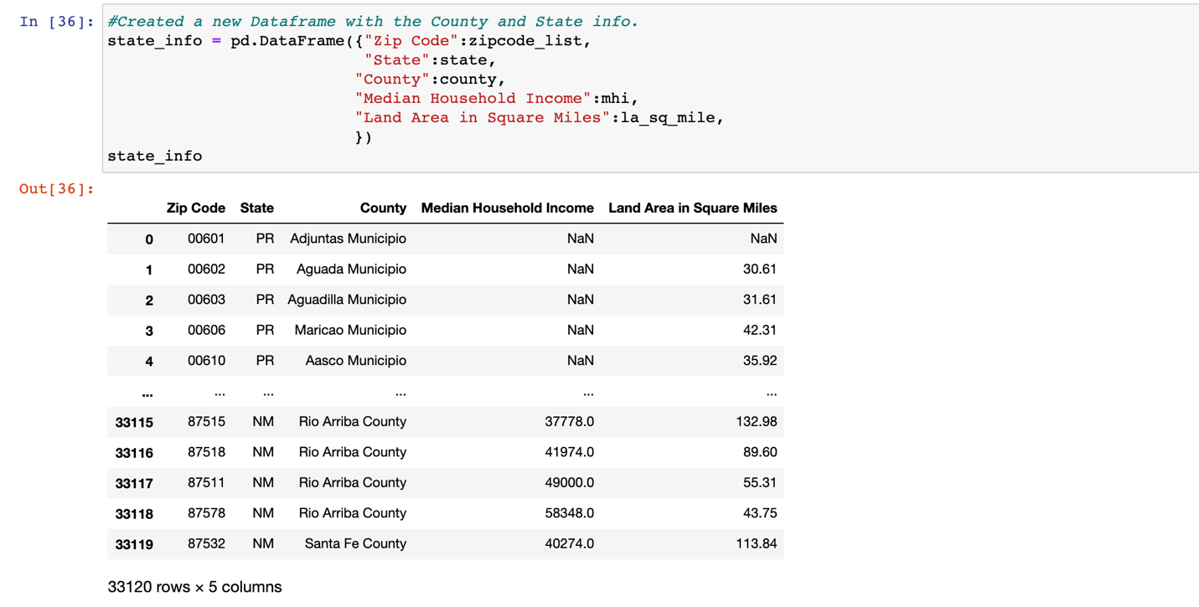

And finally, export the csv.



For Age groups, we first download the libraries.

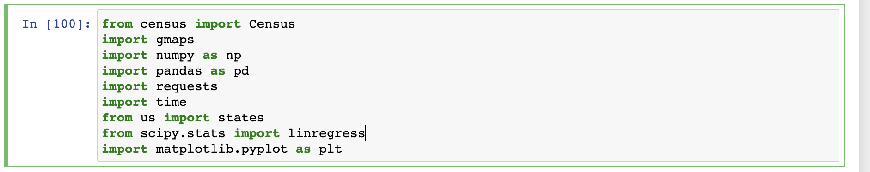

Load a csv from the CDC website containing info on number of deaths by age bracket for nationwide and state level.

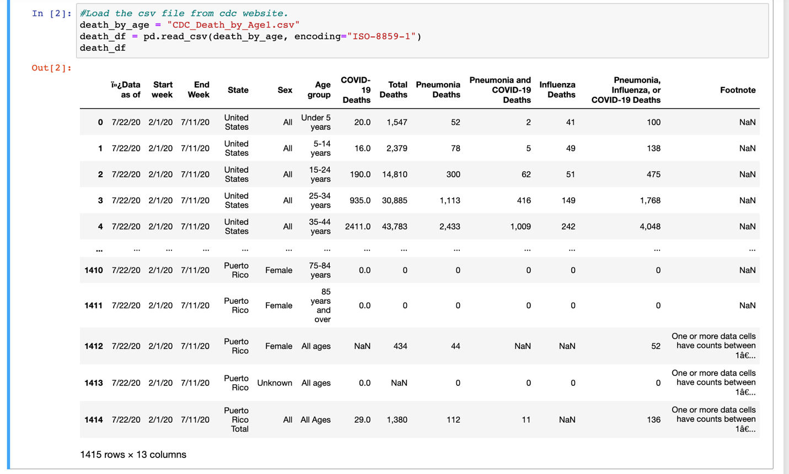

Delete Columns that were no needed

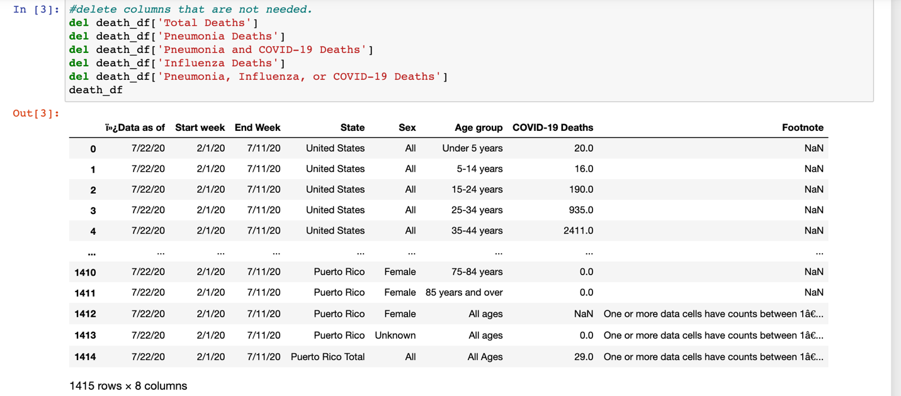

Locate just the rows pertaining to national data.

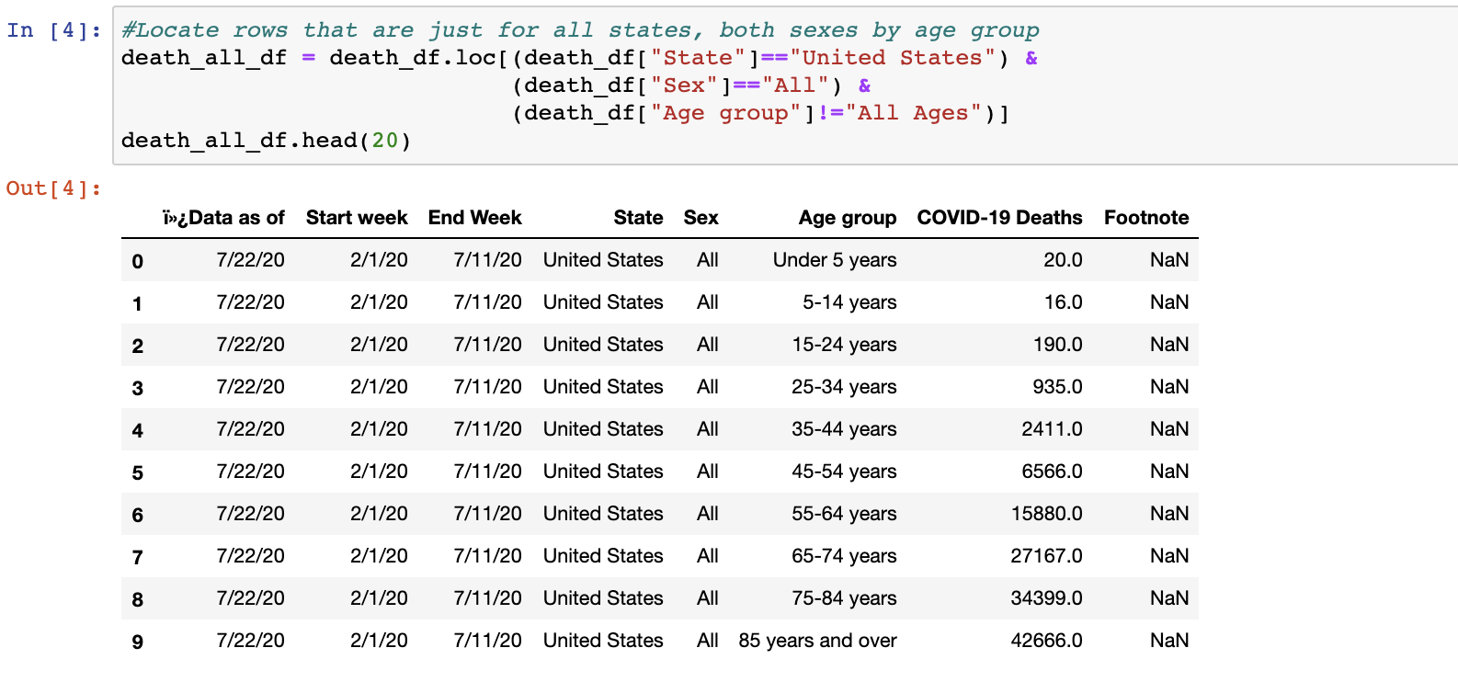

Clean up Column headings

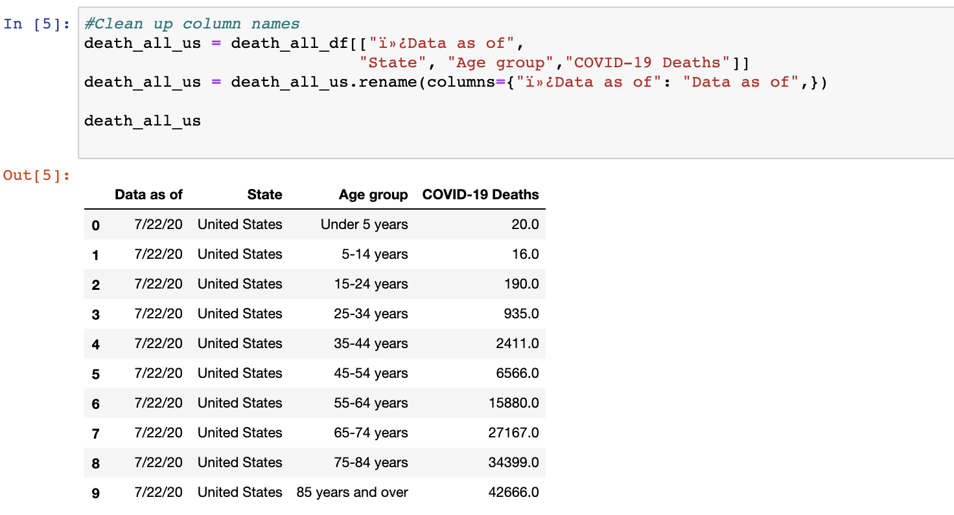

Load Census data downloaded from the Census website.

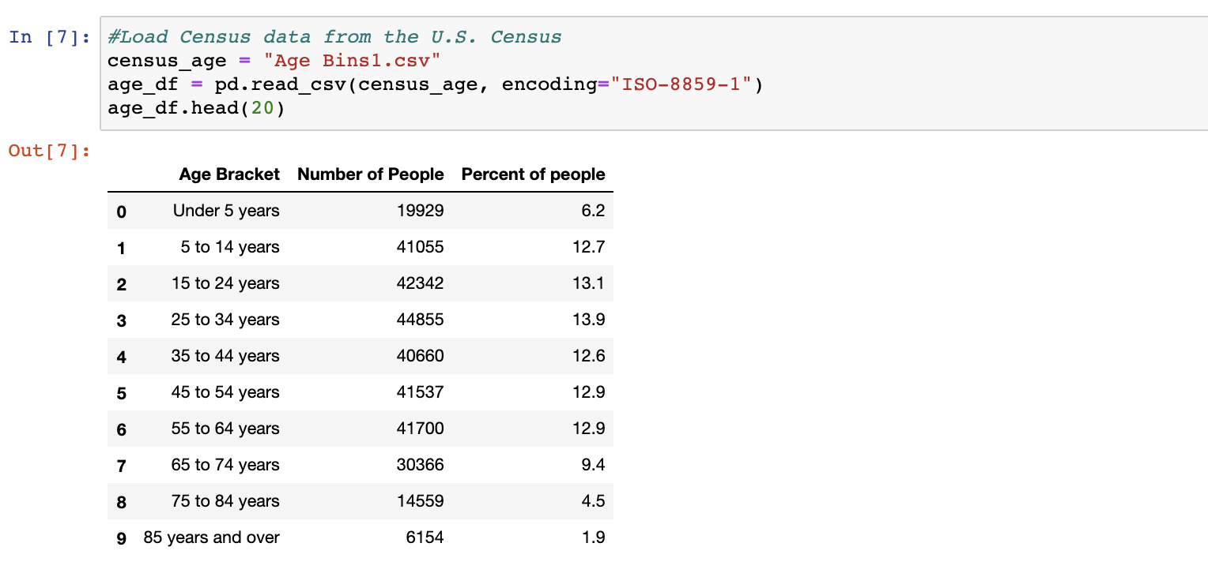

Create two pie charts showing Populations by age bracket and Covid-19 Deaths by age bracket.

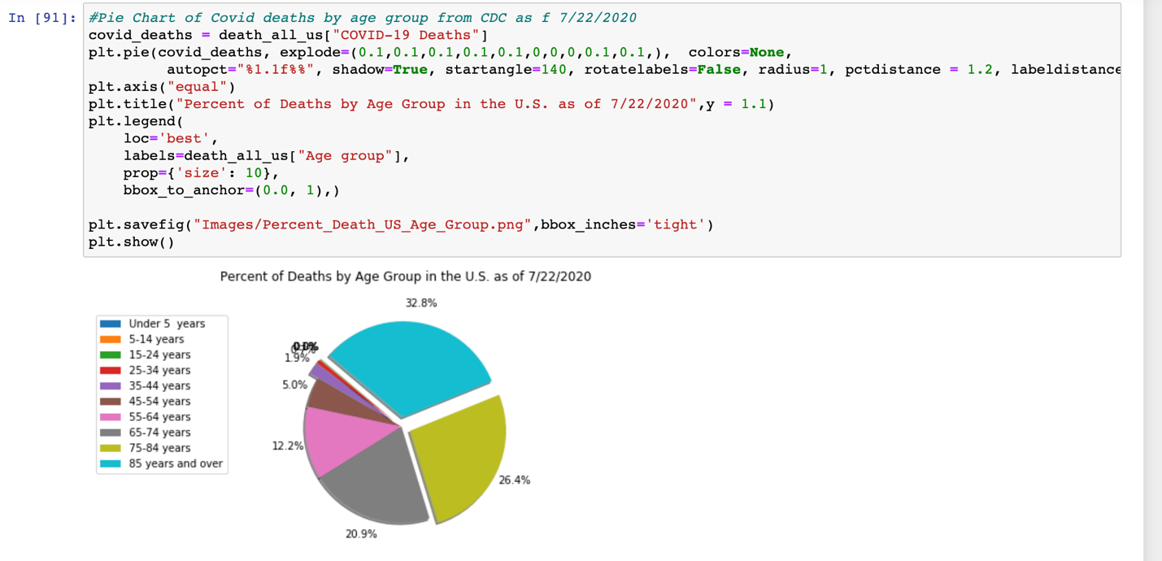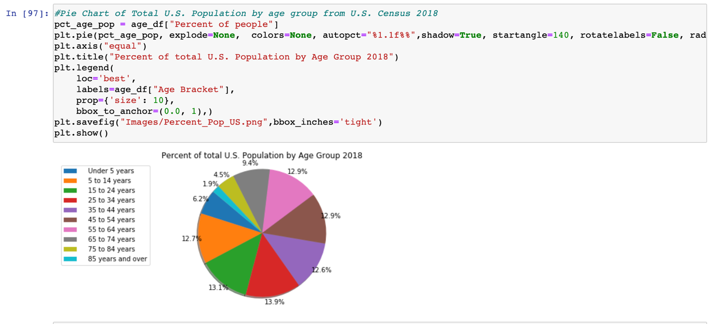

We searched for the states with the five highest rates of death from Covid-19

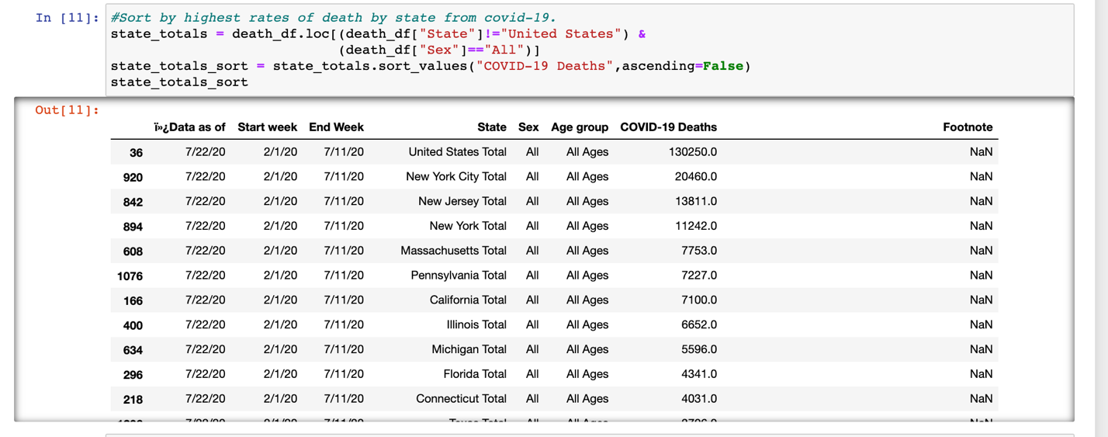

To save time we manually updated the csv file to combine data and reimported it.



Cleaned up the column headings.

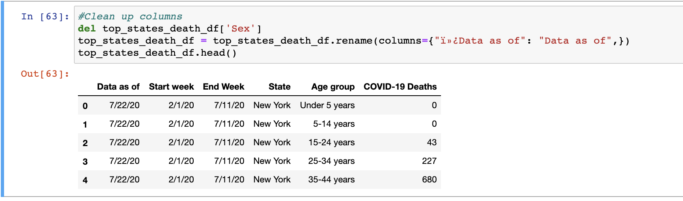

Created variables for each of the top five states.

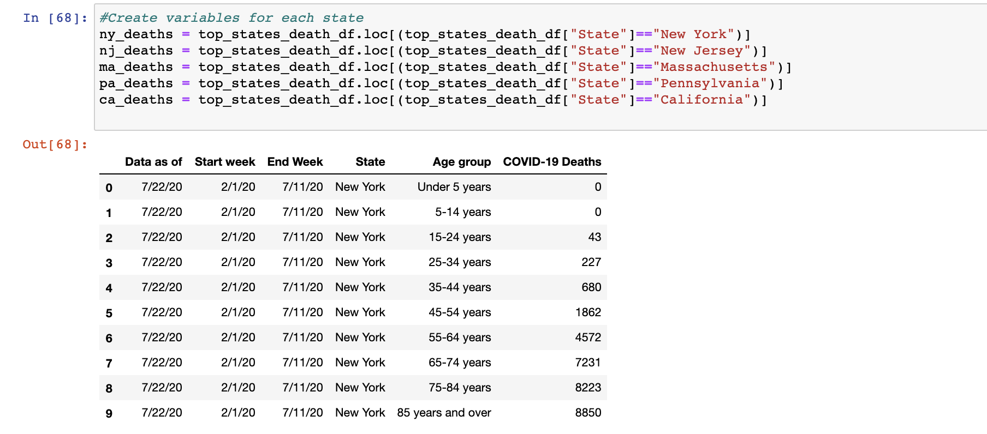

And created pie charts for each of the five states with New York given as an example.

